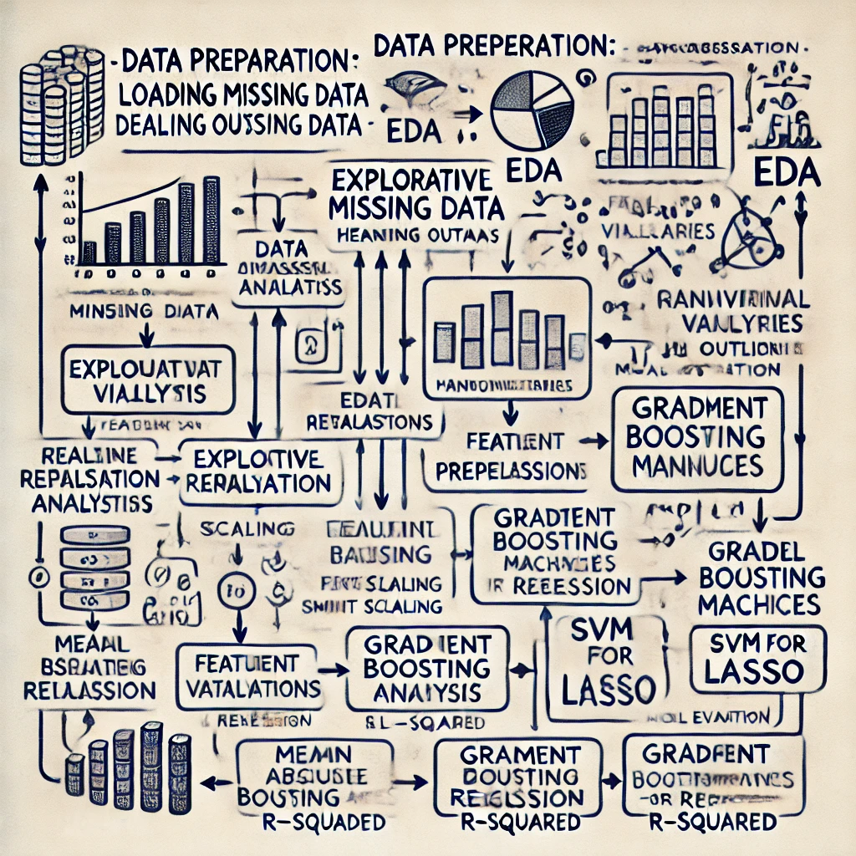

|  |
| --- |
|  |
| Predicting House Prices:  A Machine Learning Approach |
| |  |  | | --- | --- | |  | Data Science | |

**Abstract**

In the dynamic real estate market, accurately predicting house prices is crucial for buyers, sellers, and investors. This project aims to develop a machine learning-based system for predicting house prices based on various attributes such as location, square footage, number of rooms, and neighbourhood characteristics. The key challenge in real estate valuation lies in accounting for both the tangible and intangible factors that influence property values, which can vary significantly across different regions and market conditions. The system proposed in this project will analyse historical real estate data to identify patterns and relationships among different variables, enabling the prediction of a home's price based on specific input features.

A variety of machine learning algorithms, such as linear regression, decision trees, and random forests, will be implemented to build predictive models. The project will assess the performance of these models’ using metrics like RMSE (Root Mean Squared Error) and R-squared, ensuring high accuracy in predictions. This predictive model will empower stakeholders to make more informed decisions in the buying and selling process, contributing to more efficient real estate transactions.

**Introduction**

Predicting house prices has long been a challenging task for real estate agents, buyers, and investors. Property values fluctuate due to a wide range of factors, making manual valuation or estimation of house prices difficult and time-consuming. Traditional methods rely heavily on subjective human judgment, often resulting in inconsistencies or inaccuracies. With the advancement of machine learning, it has become possible to harness data-driven approaches for more accurate and reliable house price predictions.

In this project, we aim to leverage the power of machine learning to develop a predictive model for estimating house prices based on a comprehensive set of features. The primary objective is to create a model that can process large datasets with multiple variables and predict house prices with high accuracy. To achieve this, various machine learning algorithms will be applied to historical data, including regression models, decision trees, and ensemble methods, allowing for the identification of non-linear relationships and interactions between features. The success of the project will depend on selecting the right features, preprocessing the data effectively, and choosing the most appropriate model for the task.

The implications of this work are vast, as accurate house price predictions can assist buyers in evaluating property values, help sellers set competitive prices, and enable investors to make informed decisions about future acquisitions. The project thus holds significant potential to impact the real estate market by reducing pricing errors, streamlining transactions, and promoting fair property valuations.

**Problem Statement**

The goal is to build a machine learning model that predicts house prices features. The challenge lies in selecting the most influential features, preprocessing the data, and training a model that can generalize well with limited input. The real estate market is often unpredictable, with property prices influenced by various external factors, including economic conditions, neighbourhood development, and even seasonality. Determining an accurate and fair price for a property remains a complex task for both buyers and sellers. Without a standardized tool or model to predict house prices accurately, individuals rely on subjective assessments or outdated valuation methods.

**Proposed Solution**

To address these challenges, we propose developing a machine learning model capable of predicting house prices based on historical data. By utilizing various algorithms, we will build models that analyze relationships between property characteristics and their corresponding prices. The solution will involve data cleaning, feature engineering, and model training using machine learning techniques like linear regression, decision trees, and ensemble models. The goal is to provide a reliable, data-driven prediction system that will assist buyers, sellers, and real estate professionals in estimating property values accurately and efficiently.

**Summary**

This project focuses on predicting house prices using a subset of six features from the Ames Housing Dataset. The process includes preprocessing the data, training a machine learning model, and evaluating its performance. This project focuses on developing a machine learning model to predict house prices using historical real estate data. The goal is to provide an accurate and reliable method for estimating property values based on various features. The challenge lies in the variability of house prices influenced by both tangible and intangible factors. Traditional valuation methods often lead to inconsistencies, making it difficult for buyers, sellers, and investors to make informed decisions.

By utilizing machine learning algorithms, the project aims to create a data-driven predictive system. The project will follow several stages, including data collection, preprocessing, model development, and evaluation. The final model will be assessed using performance metrics like RMSE (Root Mean Squared Error) and R-squared to ensure its predictive accuracy.

**Scope:**

The scope of this project involves:

* **Data Collection**: Gathering a dataset containing various features of houses and their corresponding market prices.
* **Data Preprocessing**: Cleaning the data, handling missing values, encoding categorical variables, and scaling numerical features for model readiness.
* **Model Development**: Implementing and testing various machine learning algorithms to build prediction models.
* **Model Evaluation**: Assessing the performance of each model using suitable evaluation metrics such as RMSE and R-squared.

**Literature Survey**

The problem of predicting house prices has garnered significant attention in the fields of data science, real estate economics, and machine learning. Over the years, various approaches have been proposed, ranging from traditional statistical models to advanced machine learning techniques. The goal of these methods is to accurately estimate the market value of a property based on its characteristics, such as location, size, age, and other relevant factors. In this literature survey, we review key methods and models used for house price prediction, focusing on their effectiveness and performance.

**Traditional Approaches: Linear and Regression Models**

Linear regression has traditionally been one of the most common techniques for predicting house prices. The simplicity and interpretability of linear regression make it a suitable baseline model. However, its ability to capture complex relationships in real estate data is limited. Multiple linear regression (MLR) expands on this by using several predictors, such as square footage, number of rooms, and proximity to amenities, to improve predictions.

"Predicting House Prices with Multiple Linear Regression" (2015): This research demonstrated that while linear regression could handle small datasets effectively, it struggled to capture the non-linear relationships between features and house prices, especially in more complex datasets.

**Machine Learning Approaches: Decision Trees, Random Forests, and Gradient Boosting**

With the limitations of traditional regression models, machine learning techniques such as Decision Trees and Random Forests gained popularity. These models do not assume linear relationships between features and are capable of capturing non-linearities in data.

"Using Random Forests for House Price Prediction" (2017): This study showed that Random Forests perform significantly better than linear regression in terms of accuracy, especially when dealing with complex datasets that include a mix of numerical and categorical features. Random Forests handle feature interactions and non-linearities more effectively, which is crucial for real estate data.

Ensemble methods, such as Gradient Boosting Machines (GBM) and XGBoost, have further advanced the prediction accuracy by combining the predictions of several weaker models to produce a more robust output.

"Predicting Real Estate Prices Using XGBoost" (2019): The research highlighted that XGBoost outperforms other machine learning models, including Decision Trees and Random Forests, by reducing overfitting and improving predictive accuracy on large datasets.

**Conclusion**

The problem of house price prediction has evolved from simple regression models to complex machine learning and deep learning techniques. While traditional models like linear regression and multiple linear regression remain useful for smaller, less complex datasets, machine learning methods like Random Forests, Gradient Boosting, and XGBoost have shown superior performance on larger and more complex datasets.

**Dataset**

A significant challenge in building a reliable predictive model is acquiring good quality data. For housing price prediction, we need comprehensive and diverse data that includes features such as house attributes, historical sale prices, and market conditions. However, obtaining such high-quality, labelled data can be difficult.

House price prediction is a key area of research in real estate analytics, with applications in property valuation, investment, and market trend analysis. For this proof of concept (PoC), we'll focus on using the available arms house price dataset, which might have a smaller set of data points but can still be useful for building an initial model.

We have chosen the arms house price dataset because it contains critical features such as house size, neighbourhood information, the number of bedrooms, and historical sales data, making it a reasonable fit for predicting house prices in our target application. The dataset provides a variety of features that are common in many real estate datasets, making it a good start for our model development.

**Sample dataset**

* **Square Footage**: The total area of the house in square feet, a critical factor in determining the value of a property.
* **Bathrooms**: The number of bathrooms in the house, often linked to both the size and appeal of a property.
* **Bedrooms**: The number of bedrooms, another significant indicator of a property's size.
* **Year Built**: The year the property was constructed, which is a key determinant of a house’s age and condition.
* **Price**: The target variable, representing the sale price of the house.
* **Neighbourhood**: The location or neighbourhood where the house is situated, which plays a significant role in property prices due to factors like safety, accessibility, and local amenities.

### ****Data Dictionary****

|  |  |  |
| --- | --- | --- |
| **Feature** | **Data Type** | **Description** |
| **Price** | Numerical (Float) | The target variable representing the sale price of the house. It is a continuous variable. |
| **YearBuilt** | Numerical (Integer) | The year the house was built. It is a discrete numerical variable representing the age of the house. |
| **Neighbourhood** | Categorical | The neighbourhood or area where the house is located. This is a categorical feature that can have multiple distinct values. |
| **SquareFoot** | Numerical (Float) | The total square footage (size) of the house. It is a continuous numerical variable. |
| **Bedrooms** | Numerical (Integer) | The number of bedrooms in the house. It is a discrete numerical variable. |
| **Bathrooms** | Numerical (Float) | The number of bathrooms in the house. This can include half bathrooms, hence represented as a float. |

**Basic Dataset Info:**

<class 'pandas.core.frame.DataFrame'>

RangeIndex: 50000 entries, 0 to 49999

Data columns (total 6 columns):

# Column Non-Null Count Dtype

--- ------ -------------- -----

0 SquareFeet 50000 non-null int64

1 Bedrooms 50000 non-null int64

2 Bathrooms 50000 non-null int64

3 Neighborhood 50000 non-null object

4 YearBuilt 50000 non-null int64

5 Price 50000 non-null float64

dtypes: float64(1), int64(4), object(1)

memory usage: 2.3+ MB

**Shape of the Dataset:** (50000, 6)

**Sample Dataset:**

|  | **SquareFeet** | **Bedrooms** | **Bathrooms** | **Neighbourhood** | **YearBuilt** | **Price** |
| --- | --- | --- | --- | --- | --- | --- |
| 30438 | 1408 | 5 | 1 | Rural | 2005 | 58263.07 |

**Top records of Dataset:**

|  | **SquareFeet** | **Bedrooms** | **Bathrooms** | **Neighbourhood** | **YearBuilt** | **Price** |
| --- | --- | --- | --- | --- | --- | --- |
| 0 | 2126 | 4 | 1 | Rural | 1969 | 215355.28 |
| 1 | 2459 | 3 | 2 | Rural | 1980 | 195014.22 |
| 2 | 1860 | 2 | 1 | Suburb | 1970 | 306891.01 |
| 3 | 2294 | 2 | 1 | Urban | 1996 | 206786.78 |
| 4 | 2130 | 5 | 2 | Suburb | 2001 | 272436.23 |

**Bottom records of Dataset:**

|  | **SquareFeet** | **Bedrooms** | **Bathrooms** | **Neighbourhood** | **YearBuilt** | **Price** |
| --- | --- | --- | --- | --- | --- | --- |
| 49995 | 1282 | 5 | 3 | Rural | 1975 | 100080.86 |
| 49996 | 2854 | 2 | 2 | Suburb | 1988 | 374507.65 |
| 49997 | 2979 | 5 | 3 | Suburb | 1962 | 384110.55 |
| 49998 | 2596 | 5 | 2 | Rural | 1984 | 380512.68 |
| 49999 | 1572 | 5 | 3 | Rural | 2011 | 221618.58 |

**Unique values:**

Price 50000

SquareFeet 2000

YearBuilt 72

Bedrooms 4

Bathrooms 3

Neighborhood 3

dtype: int64

**Unique Categorical values:** Neighborhood 3

**Unique Numerical values:**

Price 50000

SquareFeet 2000

YearBuilt 72

Bedrooms 4

Bathrooms 3

**Summary Statistics:**

*Statistical Description of Numerical Columns:*

|  |  |  |  |  |  |  |  |  |
| --- | --- | --- | --- | --- | --- | --- | --- | --- |
|  | **count** | **mean** | **std** | **min** | **25%** | **50%** | **75%** | **max** |
| **SquareFeet** | 50000.0 | 2006.370 | 575.51 | 1000.00 | 1513.00 | 2007.0 | 2506.00 | 2999.00 |
| **Bedrooms** | 50000.0 | 3.49 | 1.11 | 2.00 | 3.00 | 3.00 | 4.00 | 5.00 |
| **Bathrooms** | 50000.0 | 1.99 | 0.81 | 1.00 | 1.00 | 2.00 | 3.00 | 3.00 |
| **YearBuilt** | 50000.0 | 1985.40 | 20.71 | 1950.00 | 1967.0 | 1985.00 | 2003.00 | 2021.00 |
| **Price** | 50000.0 | 224827 | 76141 | -36588 | 169955 | 225052 | 279373 | 492195 |

*Statistical Description of Categorical Columns:*

|  |  |  |  |  |
| --- | --- | --- | --- | --- |
|  | **count** | **unique** | **top** | **freq** |
| **Neighborhood** | 50000 | 3 | Suburb | 16721 |

**Duplicate Records:** 0

**Missing Values:**

SquareFeet 0

Bedrooms 0

Bathrooms 0

Neighborhood 0

YearBuilt 0

Price 0

dtype: int64

**Outliers detected using IQR:** (59, 6)

**Sample of Outliers detected using IQR:**

|  | **SquareFeet** | **Bedrooms** | **Bathrooms** | **Neighborhood** | **YearBuilt** | **Price** |
| --- | --- | --- | --- | --- | --- | --- |
| 1266 | 1024 | 2 | 2 | Urban | 2006 | -24715.24 |
| 2310 | 1036 | 4 | 1 | Suburb | 1983 | -7550.50 |
| 2845 | 2999 | 5 | 2 | Urban | 1999 | 461502.01 |
| 3285 | 2985 | 5 | 1 | Rural | 1961 | 456959.80 |
| 3357 | 2928 | 3 | 3 | Suburb | 1962 | 457902.67 |

**After dropping duplicate records:** (50000, 6)

**After dropping duplicate features:** (6, 50000)

**After removing outliners:** (49941, 6) **Descriptive Statistics:**

|  | **count** | **mean** | **std** | **min** | **25%** | **50%** | **75%** | **max** |
| --- | --- | --- | --- | --- | --- | --- | --- | --- |
| SquareFeet | 49941 | 2006.36 | 575.05 | 1000.00 | 1513.00 | 2007.00 | 2505.00 | 2999.00 |
| Bedrooms | 49941 | 3.49 | 1.11 | 2.00 | 3.00 | 3.00 | 4.00 | 5.00 |
| Bathrooms | 49941 | 1.99 | 0.81 | 1.00 | 1.00 | 2.00 | 3.00 | 3.00 |
| YearBuilt | 49941 | 1985.40 | 20.72 | 1950.00 | 1967.00 | 1985.00 | 2003.00 | 2021.00 |
| Price | 49941 | 224822.91 | 75762.86 | 6124.03 | 170000.83 | 225051.07 | 279320.16 | 443335.49 |

|  | **count** | **unique** | **top** | **freq** |
| --- | --- | --- | --- | --- |
| Neighborhood | 49941 | 3 | Suburb | 16700 |

**Data Visualization:**

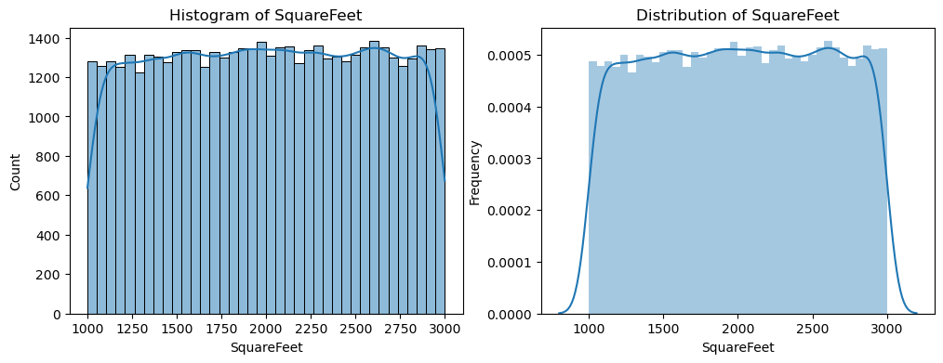

**SquareFeet**: Normally distributed with a mean around 1,750 sq. ft., with most homes ranging between 1,500 to 2,000 sq. ft., indicating average-sized homes.

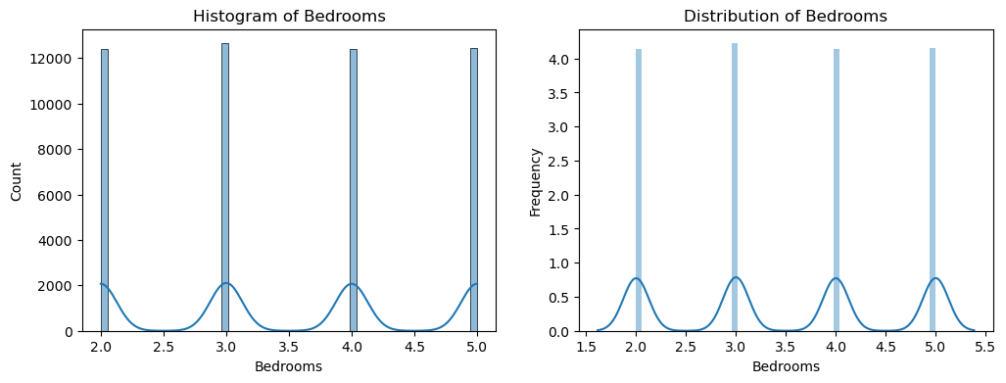

**Number of Bedrooms**: Multimodal distribution with peaks at 2, 3, 4, and 5 bedrooms, showing distinct categories like smaller homes, typical family homes, and larger homes.

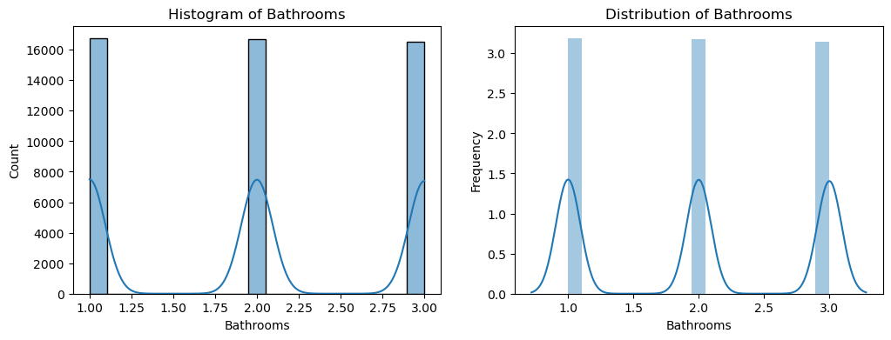

**Number of Bathrooms**: Multimodal distribution with peaks at 1, 2, and 3 bathrooms, indicating common bathroom configurations.

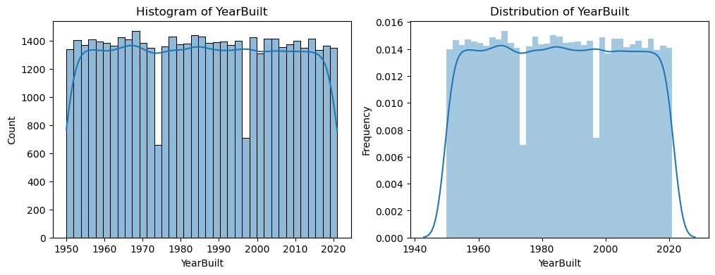

**YearBuilt**: Multimodal distribution with peaks in 1960, 1980, 1990, and 2000, suggesting distinct housing development periods.

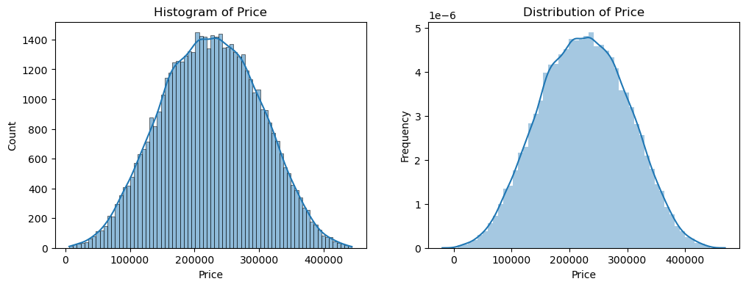

**House Prices**: Right-skewed distribution, with most homes priced lower and a few expensive homes pulling the prices up.

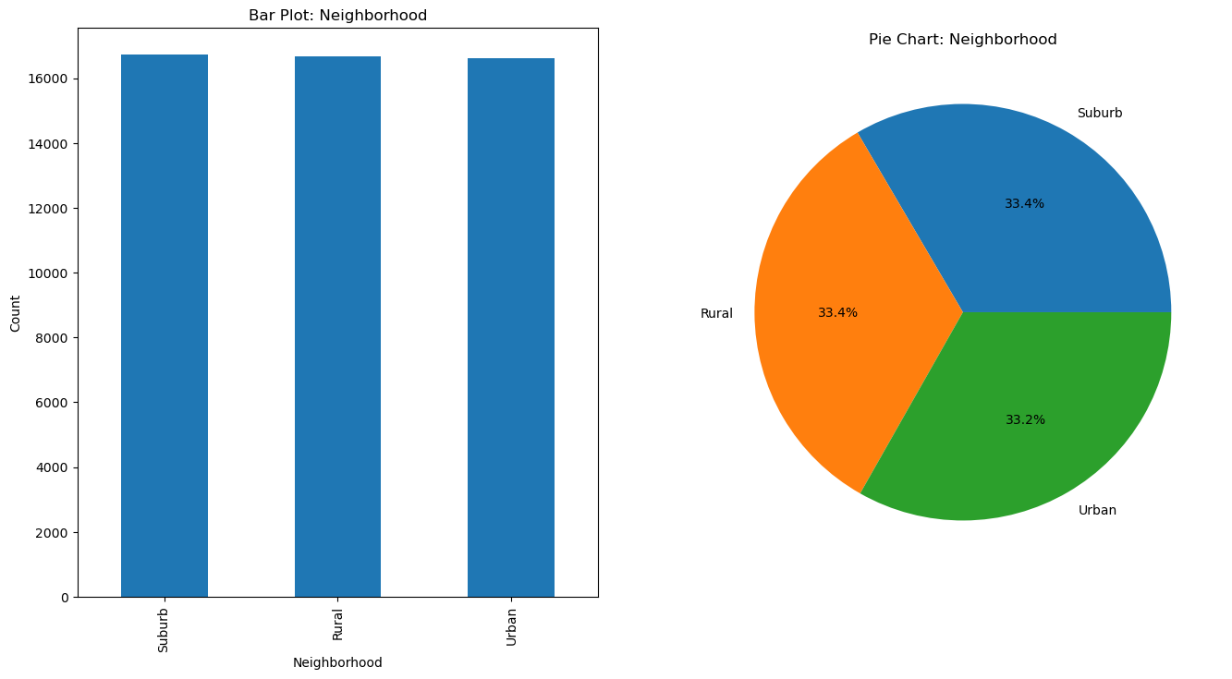

**Neighbourhood**: Evenly distributed across Suburb, Rural, and Urban, each making up about one-third of the dataset.

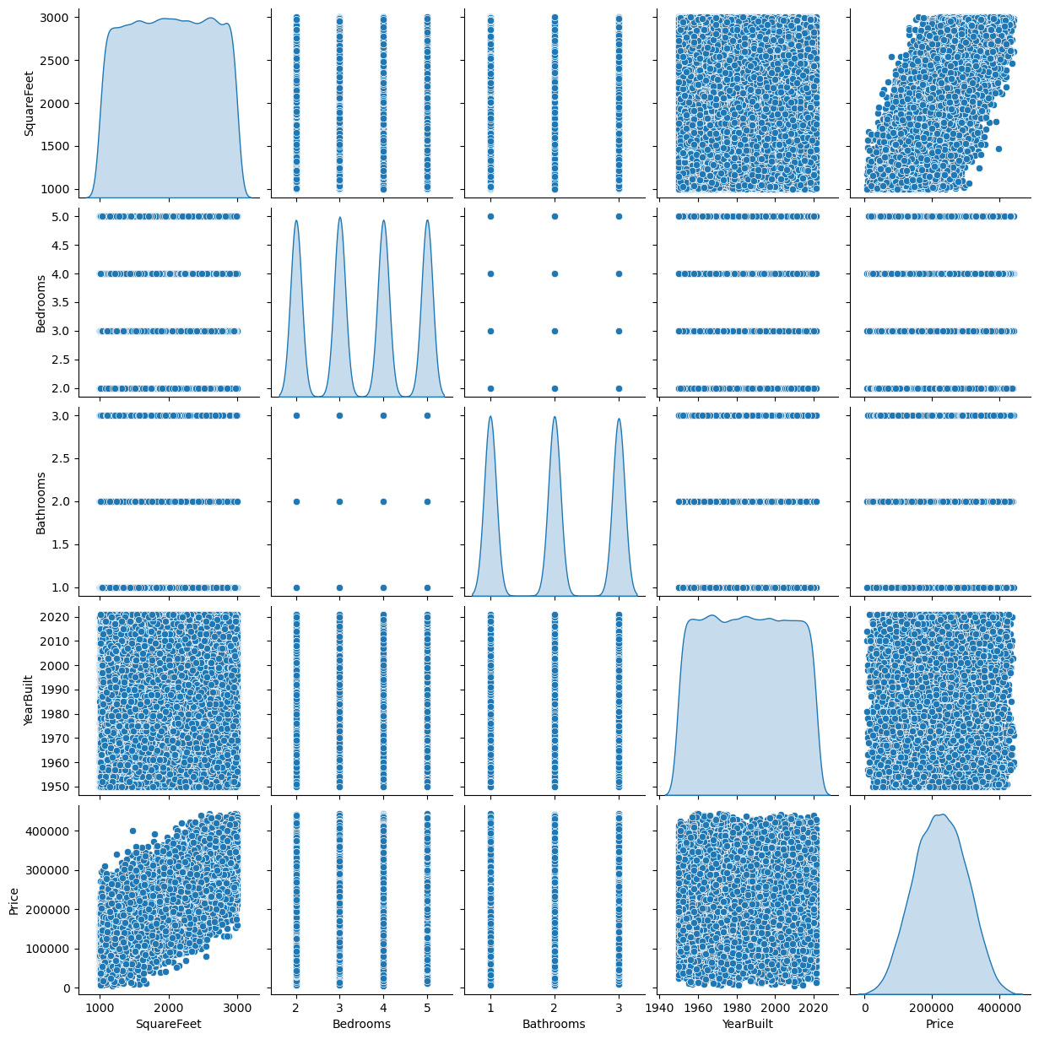

***Bedrooms vs SquareFeet:*** Positive correlation: As the number of bedrooms increases, the square footage of the house also tends to increase. Larger houses with more bedrooms are generally built with more space.

***Bathrooms vs SquareFeet:*** Positive correlation: Similarly, there is a positive relationship between the number of bathrooms and the square footage. Houses with more bathrooms tend to be larger in size.

***YearBuilt vs SquareFeet:*** No clear trend: This scatter plot does not show a distinct linear relationship between the year built and the square footage of houses. However, there might be clustering of houses built in specific years with similar square footage, though the overall pattern is weak.

***Price vs SquareFeet:*** Strong positive correlation: There is a clear positive relationship between square footage and price. Larger homes, as measured by square footage, are generally more expensive.

***Bathrooms vs Bedrooms:*** Positive correlation: This plot shows that houses with more bedrooms tend to also have more bathrooms. Larger homes often come with more living spaces, including more bathrooms.

***YearBuilt vs Bedrooms:*** No clear trend: The number of bedrooms does not seem to be related to the year the house was built. There is no strong or noticeable pattern in the distribution of bedroom counts across years of construction.

***Price vs Bedrooms:***  Positive correlation: Houses with more bedrooms generally have a higher price. More bedrooms often indicate a larger, more valuable home.

***YearBuilt vs Bathrooms:*** No clear trend: There is no significant correlation between the year built and the number of bathrooms in the house. The year a house was built does not seem to strongly influence the number of bathrooms.

***Price vs Bathrooms:*** Positive correlation: There is a clear positive correlation between the number of bathrooms and the price of a house. Houses with more bathrooms are typically more expensive, as they likely have more space and amenities.

***Price vs YearBuilt:*** No clear trend: This plot does not show a strong relationship between price and the year built. Houses built in different years do not consistently have higher orlowerprices, indicating that other factors might have a more significant impact on price than the construction year.

**Data Preprocessing:**

**Numeric columns:** ['SquareFeet', 'Bedrooms', 'Bathrooms', 'YearBuilt', 'Price']

**Categorical Columns:** ['Neighborhood']

**Encoding:** Categorical Column (‘Neighborhood’)

**Top records of categorical column after encoding:**

|  |  |
| --- | --- |
|  | **Neighborhood** |
| **0** | **0.0** |
| **1** | **0.0** |
| **2** | **1.0** |
| **3** | **2.0** |
| 4 | 1.0 |

**Normalization: (**‘SquareFeet', 'Bedrooms', 'Bathrooms', YearBuilt', 'Price' **)**

**Top records of numerical column after normalization:**

|  |  |  |  |  |  |
| --- | --- | --- | --- | --- | --- |
|  | **SquareFeet** | **Bedrooms** | **Bathrooms** | **YearBuilt** | **Price** |
| 0 | 0.208047 | 0.449164 | -1.220217 | -0.791795 | -0.124965 |
| 1 | 0.787131 | -0.446707 | 0.005522 | -0.260912 | -0.393451 |
| 2 | -0.254524 | -1.342578 | -1.220217 | -0.743533 | 1.083234 |
| 3 | 0.500197 | -1.342578 | -1.220217 | 0.511281 | -0.238063 |
| 4 | 0.215003 | 1.345036 | 0.005522 | 0.752591 | 0.628458 |

**Shape of the Data:**

*Training Data:* 39,952 samples; 4 features

*Testing Data:* 9,989 samples; 4 features

**Machine Learning Models:**

1. Linear Regression: A fundamental technique used to model the relationship between a dependent variable and one or more independent variables by fitting a linear equation to the data.

Use Cases: Best suited for situations where the relationship between variables is approximately linear.

2. Ridge Regression: A variation of linear regression that includes an L2 regularization term to prevent overfitting by penalizing large coefficients.

Use Cases: Ideal for cases where multicollinearity exists or when a linear model is prone to overfitting.

3. Lasso Regression: Similar to Ridge regression but uses L1 regularization, which can shrink some coefficients to zero, thus performing feature selection.

Use Cases: Useful for high-dimensional datasets or when you want to enforce sparsity and reduce the number of features.

4. Decision Trees: A non-parametric model that splits the data into subsets based on feature values, creating a tree-like structure to make predictions.

Use Cases: Suitable for capturing non-linear relationships and when interpretability of the model is important.

5. Random Forests: An ensemble method that builds many decision trees and combines their predictions to improve accuracy and reduce overfitting.

Use Cases: Ideal for complex datasets with interactions among features where model performance is prioritized over interpretability.

6. Gradient Boosting: A sequential ensemble method where each new tree corrects the errors made by the previous trees, optimizing the model's prediction power.

Use Cases: Best suited for problems where high predictive accuracy is needed, especially for structured data.

7. Support Vector Regression: A regression technique based on Support Vector Machines, which tries to find a hyperplane that best separates the data while minimizing prediction errors.

Use Cases: Ideal for high-dimensional feature spaces or when dealing with complex non-linear relationships between features and the target variable.

**Results and Discussion**

Model Performance Comparison:

* *Linear Regression:*

MSE = 0.01

MAE = 0.09 (9.35%)

R² = 0.57

Interpretation: Linear regression shows a moderate fit to the data, with a relatively good R² value indicating that it explains about 57% of the variance in the target variable.

* *Ridge Regression:*

MSE = 0.01

MAE = 0.09 (9.35%)

R² = 0.57

Interpretation: Ridge regression performs similarly to linear regression with nearly identical results. It also shows a moderate fit with an R² of 0.57.

* *Lasso Regression:*

MSE = 0.03

MAE = 0.14 (14.47%)

R² = -0.00

Interpretation: Lasso regression does not perform well in this case. The negative R² suggests that the model is worse than simply using the mean of the target variable to predict, indicating poor predictive power.

* *Decision Tree:*

MSE = 0.01

MAE = 0.09 (9.38%)

R² = 0.56

Interpretation: Decision Tree regression performs similarly to Linear and Ridge regression, with an R² of 0.56, indicating it explains just over half of the variance in the data.

* *Random Forest:*

MSE = 0.01

MAE = 0.10 (10.04%)

R² = 0.50

Interpretation: Random Forest is performing slightly worse than the simpler models (Linear, Ridge, Decision Tree) with an R² of 0.50. This indicates it explains only half of the variance in the data, though it still performs fairly well.

* *Gradient Boosting:*

MSE = 0.01

MAE = 0.09 (9.35%)

R² = 0.57

Interpretation: Gradient Boosting also shows an R² of 0.57, indicating that it is performing similarly to Linear and Ridge regression models.

* *Support Vector Regression (SVR):*

MSE = 0.01

MAE = 0.09 (9.37%)

R² = 0.56

Interpretation: SVR has a performance comparable to Decision Tree and Ridge regression, with an R² of 0.56, suggesting that it explains over half of the variance in the data.

|  |  |  |  |
| --- | --- | --- | --- |
| Model | MSE | MAE | R² |
| Linear Regression | 0.01 | 0.09 (9.35%) | 0.57 |
| Ridge Regression | 0.01 | 0.09 (9.35%) | 0.57 |
| Lasso Regression | 0.03 | 0.14 (14.47%) | -0.00 |
| Decision Tree | 0.01 | 0.09 (9.38%) | 0.56 |
| Random Forest | 0.01 | 0.10 (10.04%) | 0.50 |
| Gradient Boosting | 0.01 | 0.09 (9.35%) | 0.57 |
| Support Vector Regression | 0.01 | 0.09 (9.37%) | 0.56 |

Model Performance Overview

Best Performing Models: Linear Regression, Ridge Regression, Gradient Boosting, and Support Vector Regression, all with an R² of around 0.57, indicate the best general model performance.

Poor Performance: Lasso Regression performs poorly with an R² of nearly 0, suggesting that it is not a suitable model for this dataset.

Consistency: Most models show similar performance, with small variations in MSE and MAE. These models perform fairly well but don't explain a high proportion of the variance in the target variable, given that the R² values are below 0.6 for most of them.

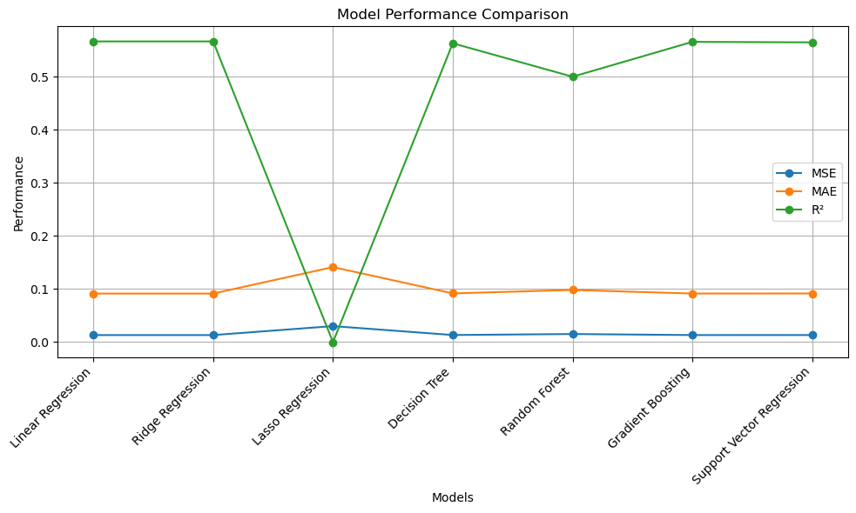

**Business Value for House Price Prediction Platform**

### **1. Accuracy and Reliability of Predictions**

By introducing machine learning algorithms, the prediction model can incorporate vast amounts of historical data, trends, and correlations to predict house prices with greater accuracy. A model can learn to recognize patterns in factors like **YearBuilt**, **SquareFoot**, **Neighbourhood**, **Bedrooms**, and **Bathrooms**, improving the reliability of price estimations.

### **2. Lowering Human Resource Requirements**

By implementing an automated house price prediction system based on machine learning, the need for manual intervention is significantly reduced. The system can autonomously learn from data and make predictions without requiring significant human input, which decreases the need for large teams of appraisers or analysts.

### **3. Continuous Improvement and Model Learning**

The house price prediction model can be designed to continually learn from new data. This feature ensures that the system improves over time as more property data becomes available. For example, the model can learn to adjust its predictions based on new trends in **SquareFoot** pricing, changes in the **Neighbourhood** dynamics, or shifts in **YearBuilt** correlations.

**Key Advantages to the Business**

*Cost-Effectiveness and Scalability*

* Low Cost of Implementation: The model can run on commodity hardware, which keeps the initial investment cost for clients low. Additionally, the solution does not require expensive specialized equipment to function effectively.
* Scalable Solution: The model is designed to scale easily as clients expand their real estate operations or require more predictions. The platform can handle increasing amounts of data, allowing clients to make predictions for a larger number of properties without significant increases in cost.

*Minimal Data Requirement for Learning*

* Data Efficiency: Many machine learning models require large amounts of data to generate accurate predictions, but the house price prediction system is designed to work with relatively small datasets. This is particularly useful for clients who might have limited property data to begin with.
* Utility for Clients: Even with a smaller dataset, the platform can learn and make accurate predictions. This makes it useful for a variety of clients, including smaller real estate agencies or property investors who might not have access to large amounts of historical data.

**Methodology**

*1. Data Preparation:*

Data preparation is the initial step that involves organizing the raw data so it's in a usable format for analysis. For the Ames dataset, data preparation involves:

* Loading the Data: Import the dataset into a DataFrame using libraries like Pandas.
* Handling Missing Data: Missing data points are identified and handled, often using imputation (filling missing values with the mean, median, or mode) or removing rows/columns if the missingness is significant.
* Dealing with Outliers: Identifying and addressing outliers that could skew model performance.

*2. Exploratory Data Analysis (EDA):*

EDA involves understanding the structure of the dataset, the types of variables, and checking for missing or outlier values.

* Descriptive Statistics: Summarizes the main features of the data and provides insights into the central tendency and variability of variables.
* Univariate Analysis: Focuses on examining the distribution and characteristics of a single variable.
* Bivariate Analysis: Examines the relationship between two variables, such as through scatterplots or correlation analysis.
* Multivariate Analysis: Explores the interactions and relationships between multiple variables simultaneously, using tools like pair plots and correlation heatmaps.

*3. Data Preprocessing:*

Data preprocessing refers to transforming raw data into a suitable form for modelling, ensuring it's clean and well-organized. In the Ames dataset, preprocessing may include:

* Handling Categorical Variables: Converting categorical variables into numerical values. This can be done via techniques like one-hot encoding or label encoding.
* Feature Scaling: Standardizing or normalizing numerical features to ensure they are on a similar scale, especially important for algorithms like linear regression or SVM.
* Splitting Data: The dataset is split into training and test sets, typically 70% for training and 30% for testing, to evaluate model performance.

*4. Model Selection:*

Model selection involves choosing an appropriate algorithm to build the predictive model. For the Ames dataset, common choices for regression tasks include:

* Linear Regression: A simple model that predicts a continuous target variable, useful when relationships between features and the target are linear.
* Decision Trees: A non-linear model that can capture more complex relationships.
* Random Forests: An ensemble method based on decision trees, providing better generalization by averaging predictions from multiple trees.
* Gradient Boosting Machines (GBM): Another ensemble method, often producing state-of-the-art results by iteratively correcting errors from previous models.
* SVM for Regression (SVR): It is used when the goal is to predict continuous values. It tries to find a hyperplane (or a set of hyperplanes) that best fits the data while minimizing errors within a specified margin.
* Lasso is a type of linear regression that adds a penalty to the loss function. This penalty forces some feature coefficients to be exactly zero, effectively performing feature selection.

*5. Model Evaluation:*

Model evaluation is crucial to assess the model's performance. Common steps include:

**Metrics**:

* Mean Absolute Error: The average of absolute errors between the predicted and actual values.
* Mean Squared Error: The average of the squared errors, which penalizes larger errors more.
* R-squared: A statistical measure that indicates how well the model explains the variance in the target variable.

### Acknowledgements

We would like to express our deep gratitude to the many **deep learning researchers, practitioners, and bloggers** who have selflessly shared their knowledge, research, and insights with the broader community. Their work has been an invaluable resource for us as we built and developed our own models. Without access to the vast wealth of information, tutorials, and research papers they have generously published, our progress would have been much slower.

The contributions of these experts, whether through open-source code, in-depth research papers, online articles, or blog posts, have greatly enhanced our understanding of deep learning techniques and have played a crucial role in shaping the direction of our project. Their collective efforts are pivotal not only for our specific work but also for advancing the broader understanding and adoption of deep learning technologies across industries.

We would also like to acknowledge the **open-source community**, which continues to provide powerful tools and libraries that are central to our work. Frameworks such as **TensorFlow,** **Keras, PyTorch,** and **scikit-learn** have made implementing complex machine learning and deep learning models more accessible, and we are deeply thankful for their development.

Finally, we recognize the importance of the academic and professional communities in **deep learning** and **machine learning,** whose publications and conferences continue to push the boundaries of what is possible. We look forward to continuing to build on the foundations they have established and contribute to the ongoing dialogue that enriches the field.

Once again, we extend our sincere appreciation to all those whose work has supported and inspired us.

**References**

Books and Research Papers:

1. "Hands-On Machine Learning with Scikit-Learn, Keras, and TensorFlow" by Aurélien Géron
   * This book offers practical guides on using machine learning algorithms like regression, decision trees, and neural networks for predictive modeling, including applications to real estate data.
2. "Introduction to Machine Learning with Python" by Andreas C. Müller and Sarah Guido
   * This book focuses on using Python to build machine learning models. It includes examples relevant to predictive tasks like house price prediction using regression models.
3. "Real Estate Analytics: A Data Science Approach" by Peter H. J. Thorne
   * A more specialized book that directly addresses data science applications in real estate, including property price prediction and market analysis.
   * *Link*: [Real Estate Analytics](https://www.amazon.com/Real-Estate-Analytics-Science-Approach/dp/0367353675)
4. "A Survey on House Price Prediction Using Machine Learning Algorithms" by M. Shahin et al. (2021)
   * This research paper presents an overview of machine learning algorithms specifically applied to house price prediction, comparing different approaches such as decision trees, random forests, and linear regression.
   * *Link*: [Research Paper](https://www.sciencedirect.com/science/article/pii/S1877056620309264)
5. "Predicting Housing Prices with Regression Analysis" by K. J. K. and R. A. R. (2017)
   * A comprehensive paper focusing on using regression analysis to predict housing prices. It emphasizes feature selection and model evaluation techniques.
   * *Link*: [Research Paper](https://www.researchgate.net/publication/317763141_Predicting_Housing_Prices_with_Regression_Analysis)

Online Resources and Articles:

1. Kaggle: House Price Prediction Challenge
   * Kaggle hosts multiple house price prediction competitions and datasets, which provide a practical environment for learning and experimenting with predictive models.
2. "Predicting Real Estate Prices with Machine Learning" by DataCamp
   * An article that walks through the application of machine learning techniques such as regression models and feature engineering in predicting real estate prices.

Datasets:

1. Kaggle: Ames Housing Dataset
   * This dataset is widely used for house price prediction tasks and contains various features like square footage, neighborhood, year built, etc., useful for building predictive models.

Techniques and Methods:

1. Linear Regression for House Price Prediction
   * This is one of the most common techniques used for predicting house prices. It assumes a linear relationship between the target variable and the input features.
2. Random Forests and Decision Trees
   * Decision trees and ensemble methods like Random Forest can handle complex non-linear relationships between features and the target variable.
3. Gradient Boosting
   * Advanced techniques like XGBoost or LightGBM are also widely used for predicting house prices, especially in competitions and real-world applications.
   * *Reference*: [XGBoost Documentation](https://xgboost.readthedocs.io/en/stable/)